海盗船 --- 黑白巡线功能

在完成基础功能后，我们对机器人来个升级，给它增加黑白巡线功能。巡线功能，是机器人最基础的功能之一。小车能够跟着事先设定好的轨道，进行自主移动。用到的是Mini巡线传感器，可帮助机器人进行黑线与白线的识别，从而实现黑白巡线。

After completing the basic functions, we’re now ready to give our robot an upgrade: black and white transmission capabilities. Transmission capabilities are among a robot’s most fundamental capabilities. The robot car is able to move along a pre-configured track or path through self-initiated movement. We’ll be using the Mini transmission sensor: using this helps the robot recognize and differentiate between the black and white lines, which in turn completes black/white transmission.

**硬件材料：**

* Mini巡线传感器V3.0 × 3 (Mini transmission sensors)

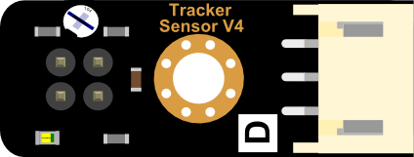

* 宽2.5cm黑胶带 × 1 (Black electrical tape)

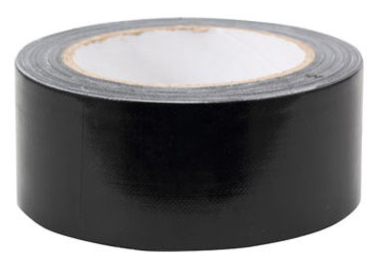

* 1cm*1cm白板 × 1 (White board)



* M3*30MM 尼龙柱(螺丝、螺母) × 3 (Nylon support (screws, nuts))

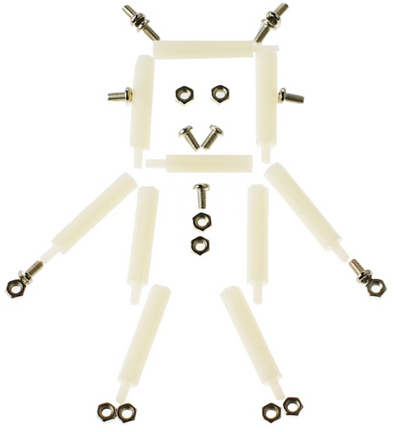

**组装步骤**

**Assembly Directions**

找到硬件材料后，就开始组装了，组装不难，更着操作就行。

After finding the necessary parts, you’re ready to start assembling. Assembly won’t be too difficult – just follow the following directions and you’ll have no problems.

**STEP 1: 摆放材料**

**Step 1: Sort out and arrange materials**

找到需要安装传感器的元件，3个M3*60MM的尼龙柱，配套的螺丝及螺母。

Find the components for the 3 sensors that need to be assembled. In addition, find the 3 nylon supports and their accompanying screws and nuts.

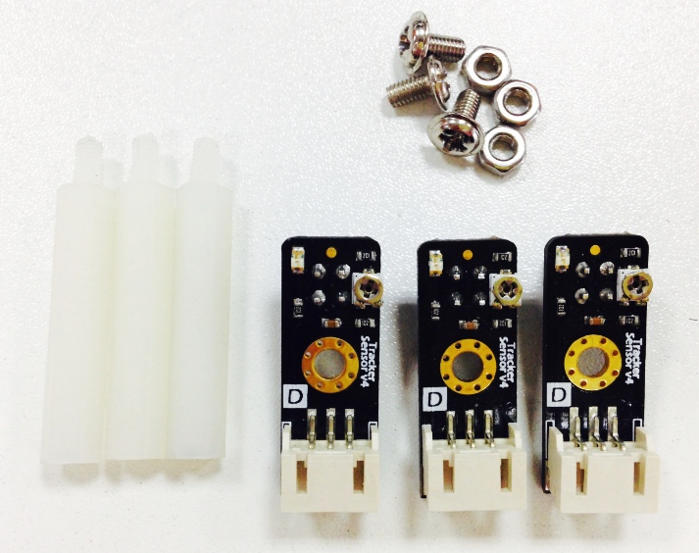

**STEP 2: 固定尼龙柱**

**Step 2: Attaching the Nylon supports**

将尼龙柱用螺母先固定到传感器上。固定时，注意方向。螺母和探头是一个方向。

Using nuts, attach the nylon supports on top of the Mini sensors. When attaching the supports, please pay attention to their direction: the nuts and probes should both be in one direction.

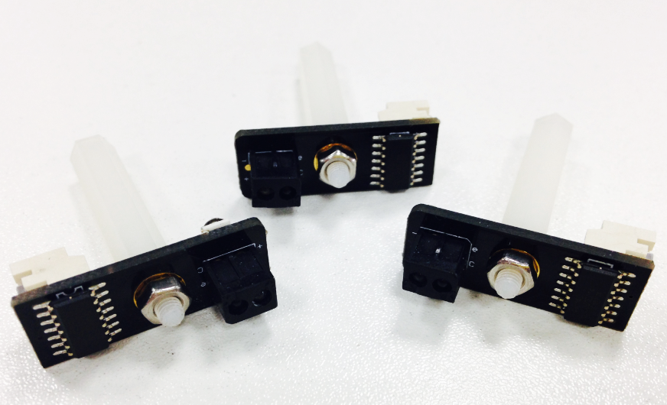

**STEP 3: 安装传感器板**

**Step 3: Assembling the sensor board**

拆下小车的上层板，并将传感器板固定于小车车头。

Remove the upper plate from the Pirate. Then, attach the sensor board to the front of the Pirate.

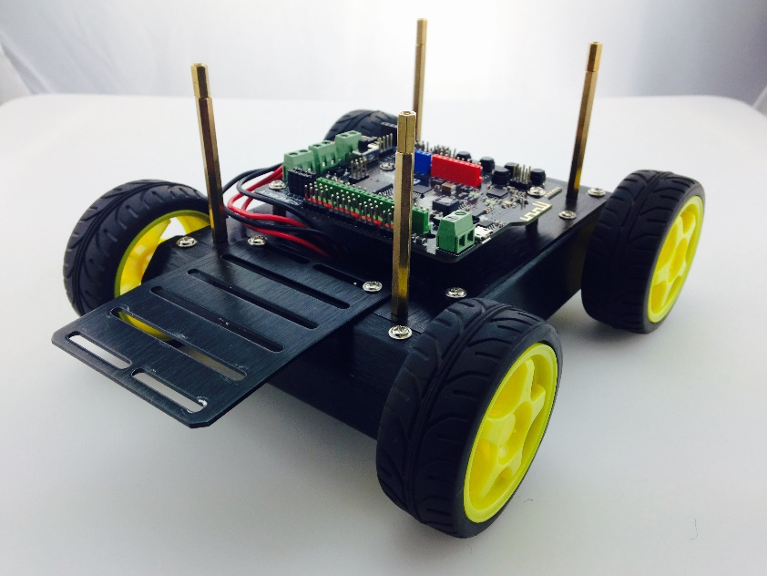

**STEP 4: 安装巡线传感器**

**Step 4: Assembling the transmission sensor**

先给传感器接上数据线，然后将其用M3螺丝固定到传感器的扩展板上。

First, connect the sensor with the wire designated for data transmission. Then, use your M3 screws to affix the sensors to the expansion board protruding from the front of the Pirate.

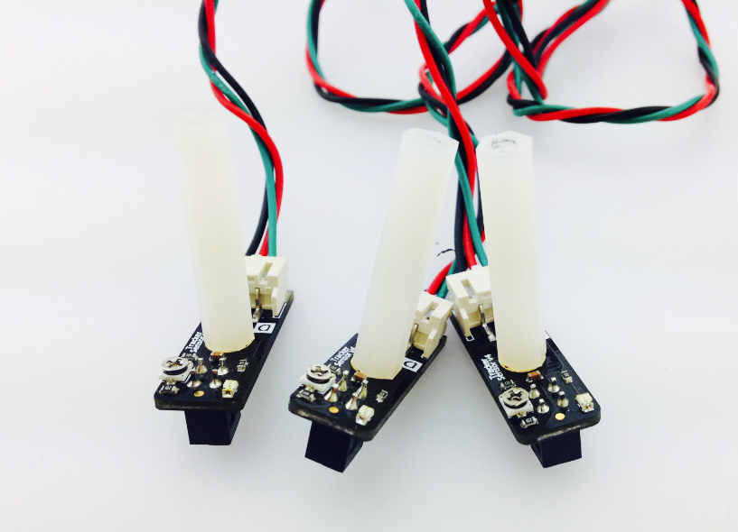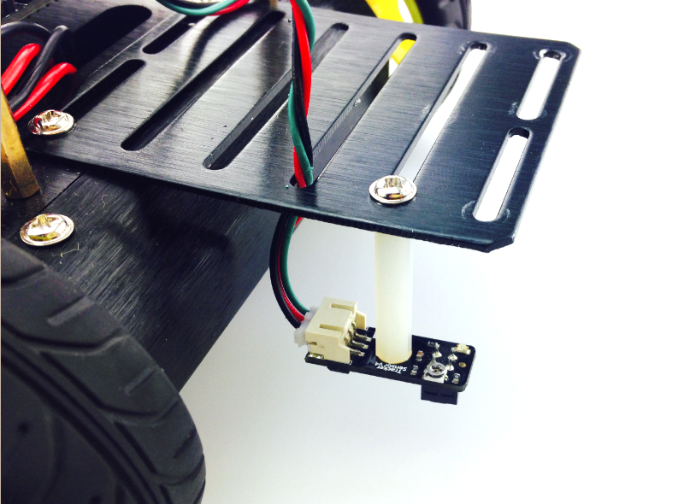

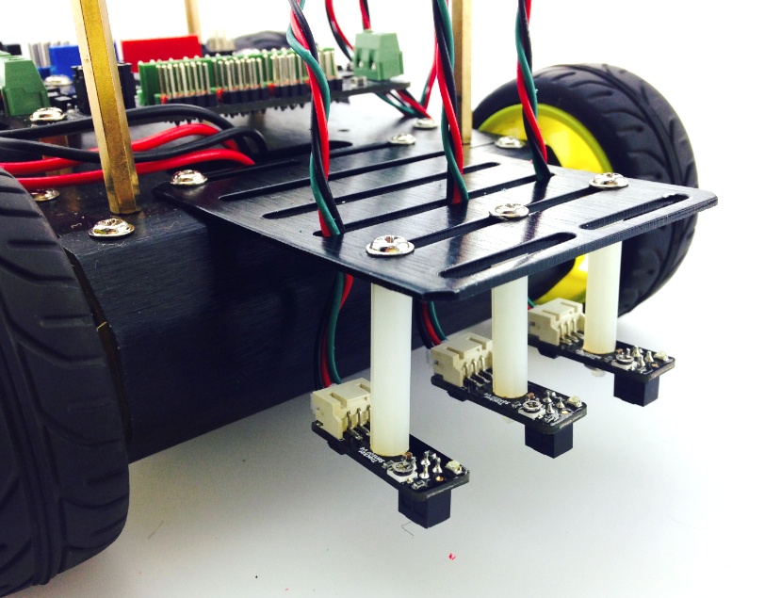

**硬件连接**

**Connecting the hardware**

传感器安装完成后，先不要急着把上层板接上去，需要将传感器与Romeo BLE控制器连接。左边这张图显示的是三个传感器ABC在小车上对应的位置，分别对应数字口的10，9，8。，连接时只需留意线序是否正确即可。 安装完成后，固定上层板。

After assembling the sensors, don’t rush to put the Pirate’s upper plate back on – before doing that, we need to first connect the sensors with the Romeo BLE control plate.

The picture on the left-hand side shows the correct ABC placement of the sensors on the sensor board, which corresponds to pins 10, 9, and 8 on the BLE board. When connecting the sensors, be sure to check that you’ve connected them in the proper sequence. After connecting the sensors, re-attach the Pirate’s upper plate back atop the base.

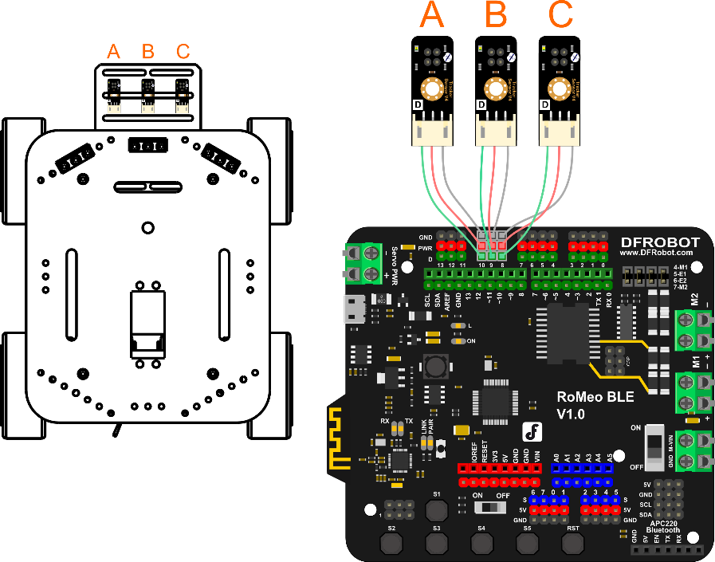

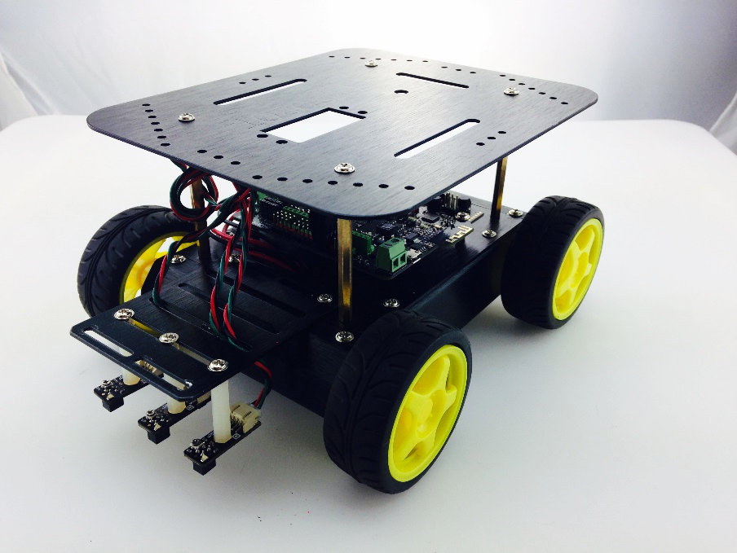

**传感器调试**

**Adjusting the sensors**

下载代码前，需要对三个传感器的做调整，先插上USB线，给板子供电。下图可见有个十字螺丝，可以用来调整传感器的探测距离。拿一张**白色纸，**放在传感器探头下，水平移动传感器，找找到传感器的探测点，一旦找到传感器上的指示灯会亮起。拿出一把螺丝刀，拧转螺丝，感受检测距离的变化，同时找到传感器检测地面黑线的最佳探测距离，推荐在2cm左右。

Before downloading code, we need to adjust our sensors. First, plug a USB cable into your BLE controller to give it power. As seen in the below picture, the sensor below has a Philips screw head; this screw head can be used to adjust the sensor’s detection of distance. Take a **white piece of paper** and place it beneath the sensor’s probe (the color of the paper is used for calibration purposes). Get a screwdriver and use it to tighten the Philips screw head. You’ll feel the sensor’s probe physically move up and down depending on how tightly you tighten the screw head. You’ll also see the sensor’s LED light up as soon as you start tightening. Tighten the screw head until the probe point is around 2 cm above the piece of paper.

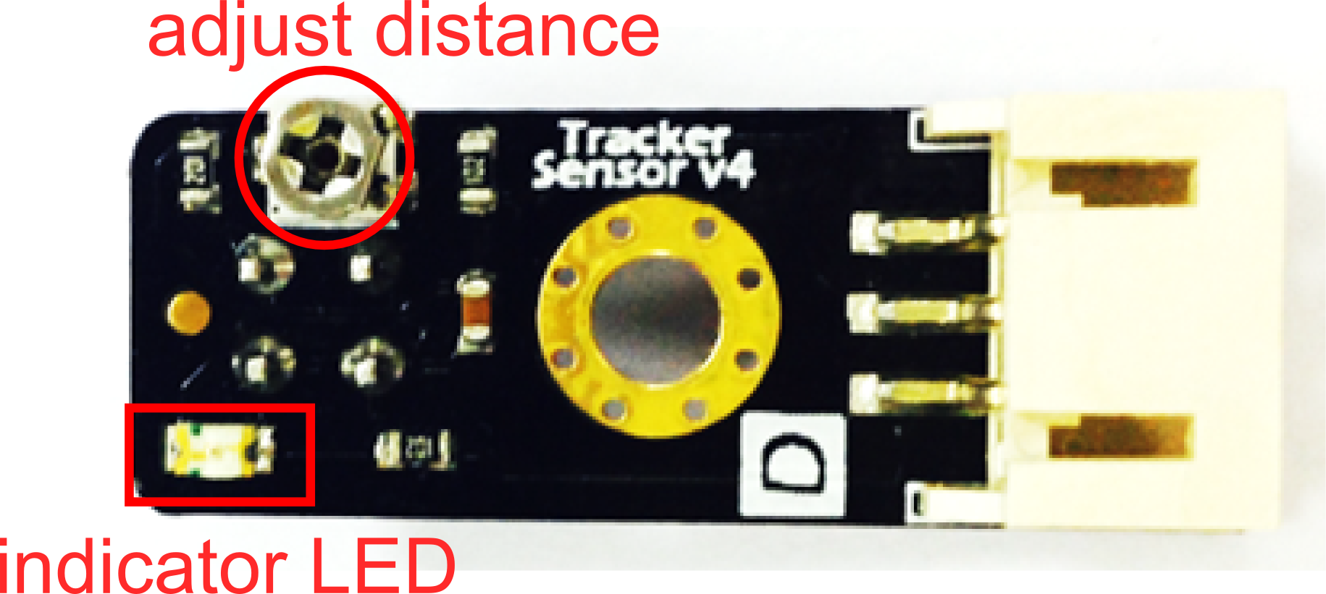

**输入代码**

**Coding the sensors**

插上USB线，下载代码。由于代码较长，所以这里就不全部显示出来，你可在软件包中找到 HuntingLineBlack.ino的代码，下载进去后即可。

Plug in your USB. Download the Arduino code, named “HuntingLineBlack.ino”, from GitHub. Click the Upload button in the Arduino IDE to upload the code to your BLE control board.

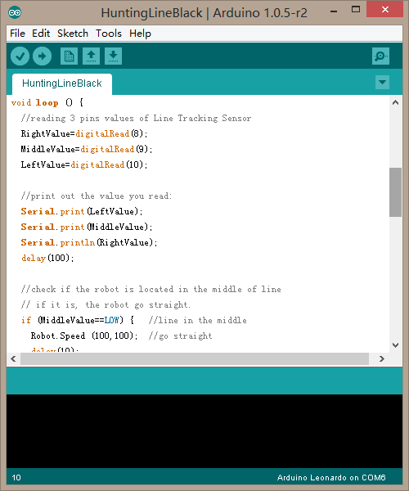

**制作轨道**

**Configuring your Pirate’s path**

用2.5cm宽的黑胶带在白板上搭出如下图所示的轨道。

Take out your whiteboard. Use your 2.5 cm wide electrical tape to lay out a path on the whiteboard as shown in the below picture.



线的宽度大约在2.5cm左右，大致在左边和右边的传感器之间。之所以这样布线的原因是由代码决定的，我们在后面一小节会介绍到。

The width of the wire is roughly 2.5 cm, the approximate distance between sensors A and C. We’ve chosen the path above for reasons relating to code; a later section will explain this reasoning more thoroughly.

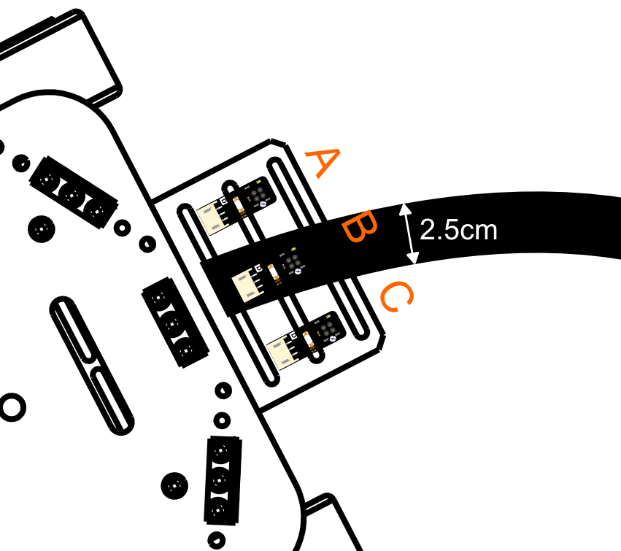

**巡线原理**

**Transmission: How it works**

怎么让小车一直跟着线走呢？我们需要让小车一直处于轨道的中间位置，一旦偏离轨道后，就进行自我调整。通过这3个巡线传感器就是来确定线的位置的。

How do we make our Pirate stay on its track? We need to ensure that the Pirate is consistently located in the middle of the track. The Pirate uses its 3 transmission sensors to calibrate its position relative to the track -- once it veers to the side, the Pirate will self-adjust back towards the middle.

小车在巡线的过程中，会出现以下三种情况：

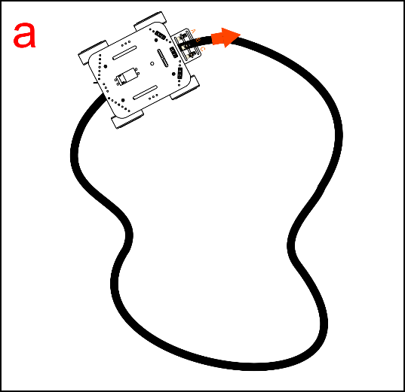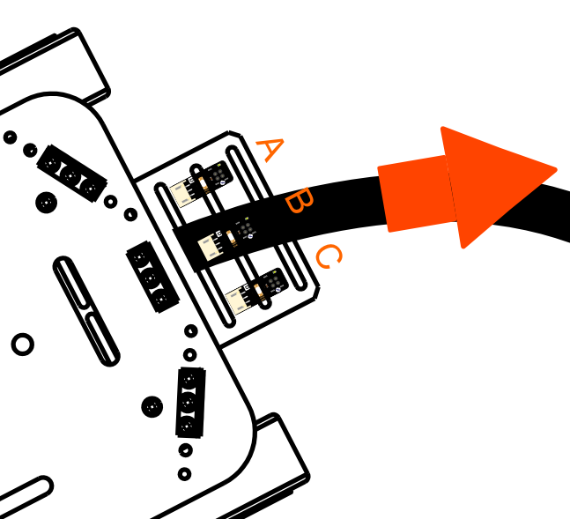

（a）小车刚一开始放入轨道的时候，只有中间的传感器检测到黑线了，左右两侧的传感器均没有检测到黑线，此时小车处于轨道的中间位置，所以小车执行前进。

When the Pirate first begins moving along the track, only the middle sensor (B) detects the black line – the left and right sensors have not come into play yet. The car will remain centered along the track and move forward.

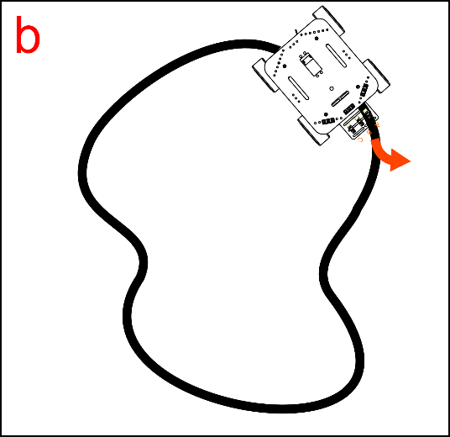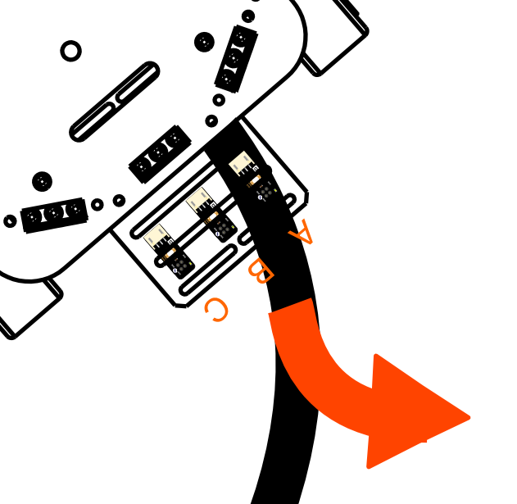

（b）走着走着，发现小车走偏了，中间传感器不在轨道上，左测传感器检测到黑线了。说明此时，小车处于黑线的右侧，所以需要让小车执行左转，进行自我调整。直到恢复中间传感器检测到黑线位置，小车才停止左转，恢复前进的状态。

After continuing on its track, the Pirate might start to veer off center. Under these circumstances, the left and right sensors will try to detect the black line and self-guide the Pirate back towards the track. For instance, if the Pirate veers towards the right side of the track, the car will need to re-center itself by turning towards the left – the left sensor will kick in and automatically turn the car until it re-centers.

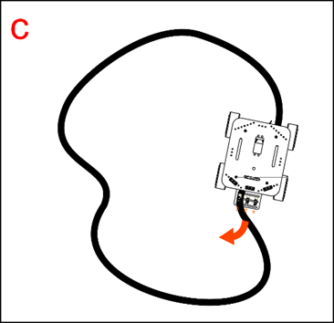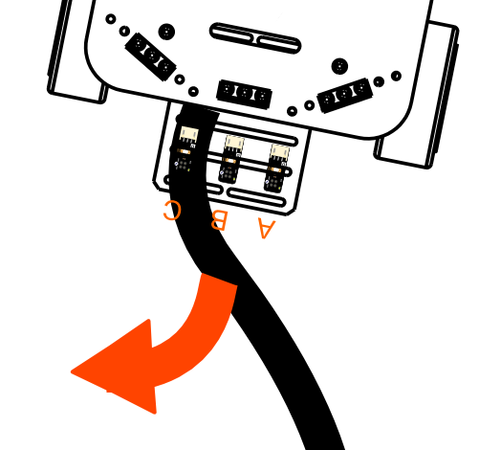

（c）相反，一旦右边传感器检测黑线了，说明小车偏离到黑线的左侧，此时需要让小车执右转了。和b情况一样，直到中间传感器检测再次检测到黑线时，才停止执行右转。

Conversely, if the Pirate veers towards the left side of the track, the right sensor will kick in and adjust the car’s path until it re-centers.

**代码回顾**

**Code Synopsis**

基础功能重复部分就不说了，只说下巡线部分的。

There’s no need to discuss the basic code – let’s just take a look at the part involving transmission.

int RightValue; //Right line tractor sensor on Pin 8

int MiddleValue; //Middle line tractor sensor on Pin 9

int LeftValue; //Left line tractor sensor on Pin 10

//reading 3 pins values of Line Tracking Sensor

RightValue=digitalRead(8);

MiddleValue=digitalRead(9);

LeftValue=digitalRead(10);

用三个变量RightValue，MiddleValue，LeftValue分别记录3个传感器读到的值，digitalRead(pin)函数就是用来读取数字口的值，不明白的可以查看下[语法手册](http://wiki.dfrobot.com.cn/index.php/Arduino%E7%BC%96%E7%A8%8B%E5%8F%82%E8%80%83%E6%89%8B%E5%86%8C%EF%BC%88%E5%A4%9A%E9%A1%B5%E9%9D%A2%E7%89%88%EF%BC%89)。

Use three variables – RightValue, MiddleValue, LeftValue – to record the 3 sensors’ read values.

The digitalRead(pin) function is used to read the digital Input/Output port value. If this part is still unclear, please check out our Terminology Manual or the Arduino website.

**巡线传感器检测到黑线后，输出一个低电平，检测到白线，输出一个高电平。**

**When the middle transmission sensor detects a black line (the track), it’ll produce a LOW energy output. When they detect a white space, they’ll produce a HIGH energy output.**

下面这段代码描述的是巡线原理中的情况a。如果中间传感器检测到黑线，也就是输出为LOW。或者左右两侧传感器检测到白，也就是输出为HIGH时。小车执行前进。

Example A below illustrates the transmission code’s working principles. When the middle sensor detects a black line (the track), it’ll produce a LOW energy output. When the left/right sensors detect white space, they’ll produce a HIGH output.

if (MiddleValue==LOW) { //line in the middle

Robot.Speed (100,100);

delay(10);

}

else if ((LeftValue==HIGH) && (RightValue==HIGH)) {

Robot.Speed (100,100);

delay(10);

}

如果一旦左边检测黑线，同时右侧检测到白线的时候，小车左转，也就是情况B：

If the sensors detect the black line/track to the left while also detecting white space to the right, the Pirate will turn left. See Example B below:

else if ((LeftValue==LOW)&&(RightValue==HIGH)){

Robot.Speed (-100,100); //turn left

delay(10);

}

相反，右边检测黑线，同时左侧检测到白线的时候，小车右转，也就是情况c：

Conversely, if the sensors detect the black line/track to the right while also detecting white space to the left, the Pirate will turn right. See Example C below:

else if ((LeftValue==HIGH)&&(RightValue==LOW)){

Robot.Speed (100,-100); //turn right

delay(10);

}

**大改造**

其实看上去很复杂的机器人是不是也不是很难？巡线传感器改造一下可以用来做防跌落小车，如果你家是上下两层的，那就可以做个这样的防跌落小车，一旦走到楼梯口，就自动避开，不会摔个“四脚朝天”了。

Wouldn’t you say that robots aren’t as hard to assemble as you might’ve thought? After upgrading your transmission, you can make your Pirate pretty much “fall-proof” – if you live in a two-floor house, for instance, your car won’t flip over helplessly the moment it encounters stairs. In this sense, transmission is a basic, useful function in building robots.